Recording and coding

of Cancers of unknown primary

and Cancers of ill-defined locations

Contents

Entering into force 2
Aim of these recommendations 2
Rules and explanations 4
Decision trees 8
Annex: Working Group Members 11

Contact: ENCR Secretariat
JRC-ENCR@ec.europa.eu

Entering into force

This recommendation is published on the website on (XX-XX-XXXX). These recommendations must be applied to all tumours with an incidence date as of X-X-202X, but may also be applied to earlier dates.

Aim of these recommendations

These recommendations aim to harmonize recording and coding cancer of unknown primary (CUPs) (i.e. cancers diagnosed in the context of metastasis (with or without histological confirmation) and for which diagnostic investigations have not identified the primary site or could not be carried out and cancers of ill-defined location, which are often analysed together in international incidence figures, even though they correspond to different situations.

The European Society for Medical Oncology (ESMO) identifies four histological groups of CUP:
- Well and moderately differentiated adenocarcinomas (50%)
- Poorly differentiated adenocarcinomas or undifferentiated carcinomas (30%)
- Squamous cell carcinomas (15%)
- Undifferentiated neoplasms (5%)
Sarcomas, melanomas, germ cell tumours, neuroendocrine tumours and haematological malignancies whose exact origin is unknown are excluded from the definition used by ESMO.

Cancer registries record:
- cancers of unknown primary, whatever their histological type, as well as those for which no histological proof could be obtained;
- cancers for which diagnostic investigations have not been completed (elderly patient and therapeutic abstention intended, death before completion of investigations, patient refusal to continue investigations, etc.).

Several situations are encountered:

- Metastatic tumour whose primary site is not found at the end of the recommended assessments;
- Metastatic tumour whose primary site is not investigated;
- Metastatic tumour with an immunohistochemical profile pointing to a CXX origin, recommended to code this in location CXX (See Decision Trees);
- Primary tumour whose starting point cannot be exactly located: this is generally a large tumour affecting several organs, for which assessment cannot find the precise starting point. If surgery is to be performed (excision or exploratory surgery), it is essential to retrieve surgical report data to help identify the topography;
- Finally, for certain sites (lung, brain, peritoneum, etc.), it is sometimes difficult to know whether the tumour recovered is the primary or a metastasis of an unidentified primary, and the opinion of the clinician must be followed, using a set of arguments to define the topography coding.

Topography coding is the main difficulty in these situations.

Before recording a CUP, it is necessary to ensure that a more precise location cannot be coded (need to have sufficient hindsight on the file as the primary may be discovered later). It is also necessary to ensure that the cancer is not a metastasis of a previous cancer (different morphology and clinicians' conviction). If clinicians cannot conclude, or if it has not been possible to carry out a medical assessment, or in case of poorly differentiated metastasis, consider that it is a progression of the first cancer and do not record a CUP. Decision trees are proposed to assist with coding (see section at the end of these recommendations).

Rules and explanations

Table 1. Locations CIMO-3 covered by these recommendations
Primary site not found or not known
Cancer of unknown primary | C80.9
Poorly defined locations in the digestive system ⁽¹⁾
Intestinal tract no other specified (NOS), intestine NOS | C26.0
Gastrointestinal tract NOS, digestive system NOS, digestive organs NOS, digestive tract NOS | C26.9
Overlapping lesions in multiple three-character categories ⁽²⁾
Tongue | C02.8
Major salivary glands | C08.8
Lip, oral cavity and pharynx | C14.8
Rectum, anus and anal canal | C21.8
Biliary tracts | C24.8
Digestive system | C26.8
Respiratory and intrathoracic | C39.8
Bones, joints and articular cartilage | C41.8
Connective, subcutaneous and other soft tissues | C49.8
Female genital organs | C57.8
Male genital organs | C63.8
Urinary organs | C68.8
Brain and central nervous system | C72.8
Other ill-defined sites ⁽³⁾
Head, face or neck, NOS ⁽⁴⁾ | C76.0
Thorax, NOS | C76.1
Abdomen, NOS | C76.2
Pelvis, NOS | C76.3
Upper limb, NOS | C76.4
Lower limb, NOS | C76.5
Other ill-defined sites (back NOS, flank NOS, trunk NOS) | C76.7
Overlapping lesion of ill-defined sites | C76.8
Kaposi's sarcoma of the lymph nodes ⁽⁵⁾
Lymph node | C77

⁽¹⁾ Without precise location (assessment not performed or negative), a tumour whose morphology or immunohistochemical profile points to a digestive origin is coded as follows:
. C26.0 if the origin is thought to be intestinal (small intestine, colon or rectum),
. C26.9 if another digestive organ is assumed (stomach, pancreas, bile ducts, alimentary tract, etc.).
⁽²⁾ A tumour that overlaps two or more CXX subcategories in the same organic system and whose starting point cannot be specified should be classified in subcategory .8 (ICD-O-3 Table 17 Rule C), unless the contiguous location exists in ICDO-3.
Examples:
. A cancer of the digestive organs whose starting point cannot be assigned to any of the categories C15 to C26.0 is coded C26.8: Ex. “Carcinoma of the stomach and small intestine” should be assigned to C26.8, overlapping lesion of digestive system.
. An oesogastric cancer is currently coded C16.0 (cardia); a cancer of the recto-sigmoid junction is coded C19.9.
. A vesicovaginal septum cancer, urethrovaginal septum cancer or vesicocervical cancer with no more specific site of origin, is coded under the topography code C57.9.
. A tubo-ovarian or utero-ovarian cancer, with no more specific site of origin, is coded as C57.8.

⁽³⁾ A tumour that overlaps several systems and whose starting point cannot be determined should be coded as C76.
Example: a tumour encompassing the tail of the pancreas (digestive system) and the kidney (urinary system) and whose starting point cannot be determined is coded C76.2 (ill-defined site of the abdomen).

⁽⁴⁾ The topographical code for cervical adenopathy without evidence of ENT tumour (cervical scan or even MRI, endoscopy, PET) depends on the histology:
. if squamous cell carcinoma: code C76.0, 8070/3, BoD = 7.2 (or 5 if cytology of metastasis)
. if different from squamous cell carcinoma: code C80.9
. if no histology and no ENT starting point after assessment or no assessment: code C80.9, 8000/3, BD = 2

⁽⁵⁾ Kaposi's sarcoma (9140/3) of lymph node topography is extremely rare; it is the only case of a solid tumour for which the topographical code C77 usually reserved for haematological malignancies (lymphomas) can be used.

The topography code C76 is not accepted with all morphologies. Before using it, it is necessary to consider the morphology as this may point towards a more precise topography (to discuss if necessary with the person responsible for coding in your registry). For example, a squamous cell carcinoma of the "thumb" suggests a C44.6 topography (skin of the thumb); the pathological report certainly states that this is a skin biopsy in which the tumour infiltrates the various skin layers to varying degrees; an osteosarcoma of the "thumb" is coded in C40.1 (bones of the thumb), and a rhabdomyosarcoma of the "thumb" in C49.1 (soft tissues of the thumb).

CUP and ill-defined cancers coded on clinical exam or investigations basis are coded 8000/3, or more specific code if accepted with BoD 2 (See ENCR recommendations on the Basis of diagnosis).

With a view to standardising coding practices, Table 2 precise what can and cannot be coded with a poorly defined or unknown topographical code for certain morphologies.

Table 2. Examples of permitted / forbidden topographies according to morphologies
Morphologies | Permitted topographies | Forbidden topographies
Melanoma | . C44  . or organ CXX (mucosa and skin of the external genital organs)  . C80.9: if metastatic melanoma whose primary site could not be identified | . C76  . C42, C77
Merkel carcinoma (8247/3)  (origin: dermo-epidermal neurotactile cells) | . C44, and skin of the external genital organs  . C80.9 if the diagnosis of Merkel cell carcinoma is made on the basis of a metastatic lesion without an identified primary site | All others
Sacrococcygeal teratoma | C76.3  A teratoma of the pelvic soft tissues other than sacrococcygeal will be coded C49.5 | All others
Sarcoma | . C49  . or CXX organ (bone sarcoma, visceral sarcoma)  . C80.9: if metastatic sarcoma whose primary location could not be identified | . C76*  . C42, C77
Peripheral neuroblastoma** | . C47  . C74.1 (medulla of adrenal gland)  . C80.9: if metastatic neuroblastoma whose primary location could not be identified | All others (including C76, C42 and C77)
Haematological malignancies | . C77  . C42  . or solid CXX (Ex. Gastric lymphoma: C16)  . C76 and C80.9 can be used for ill-defined locations of lymphomas or when primary site of lymphoma could not be identified***
Urothelial tumour | C65-66-67-68 | All others (including C76 and C80)
* ENCR does not recommend the use of the C76 topographical code for a sarcoma, although this combination is accepted by the JRC control software.
** Central neuroblastomas exist but are extremely rare; code with topography C71 or C72.
*** In accordance with ICD-O3, Rule D.

Topography coding for peritoneal tumours

Peritoneum is a serosa made up of two layers (parietal and visceral) that envelop the abdominal organs. This serosa has folds that fix the organs to the wall (mesentery) or to each other (epiploons).

Primary malignant tumours of the peritoneum are rare: mesothelioma, epithelial tumour of mullerian origin (low-grade and high-grade serous tumour), mesenchymal tumours (desmoplastic small round cell tumour and low-grade and high-grade endometrioid stromal sarcoma, extra-gastrointestinal stromal tumour).

Secondary tumours of the peritoneal serosa (= peritoneal carcinosis) are the most common and complicate disease progression of most intra-abdominal cancers (colorectal, gastric, pancreatic, ovarian, appendicular), as well as that of other primary extra-abdominal sites.

Peritoneal pseudomyxoma (8480/3) corresponds to the peritoneal metastatic spread of a tumour (most often digestive, gynaecological or other). The primary location is not always identified, but it is not a primary cancer of the peritoneum; topography cannot therefore be C48.

A serous tumour of the peritoneum should not be coded in C80.9. For women, the starting point is most often gynaecological, sometimes peritoneal. Without conclusive gynaecological assessment, case is recommended to be coded with a C57.8 topography (frequency argument). Peritoneal serous tumours are rare in men and should be coded with topography C48.2.

In case of peritoneal tumours, the determination of the primary topography is guided by tumour morphology and the imaging data assessment, but in all cases clinicians’ opinion prevails.
See situation II of the decision trees.

Base of diagnosis coding

  - The use of code 4 (specific tumour marker) is limited to certain secreting germ cell tumours (βHCG, αFP) and neuroblastoma (HVA, VMA) whose starting point could not be found; a tumour secreting insulin, glucagon or gastrin is coded with topography C25.4 (endocrine pancreas), not C80.9;
  - C80.9 with histological confirmation is coded with base of diagnosis 7.2 (histology of a regional lymph node or distant metastasis);
  - Ovarian carcinomas discovered in peritoneal carcinosis sampling are coded with base of diagnosis 7.1 (histology of primary tumour) because peritoneal metastasis are considered to be stage T3 in the TNM V8 classification.

Decision trees

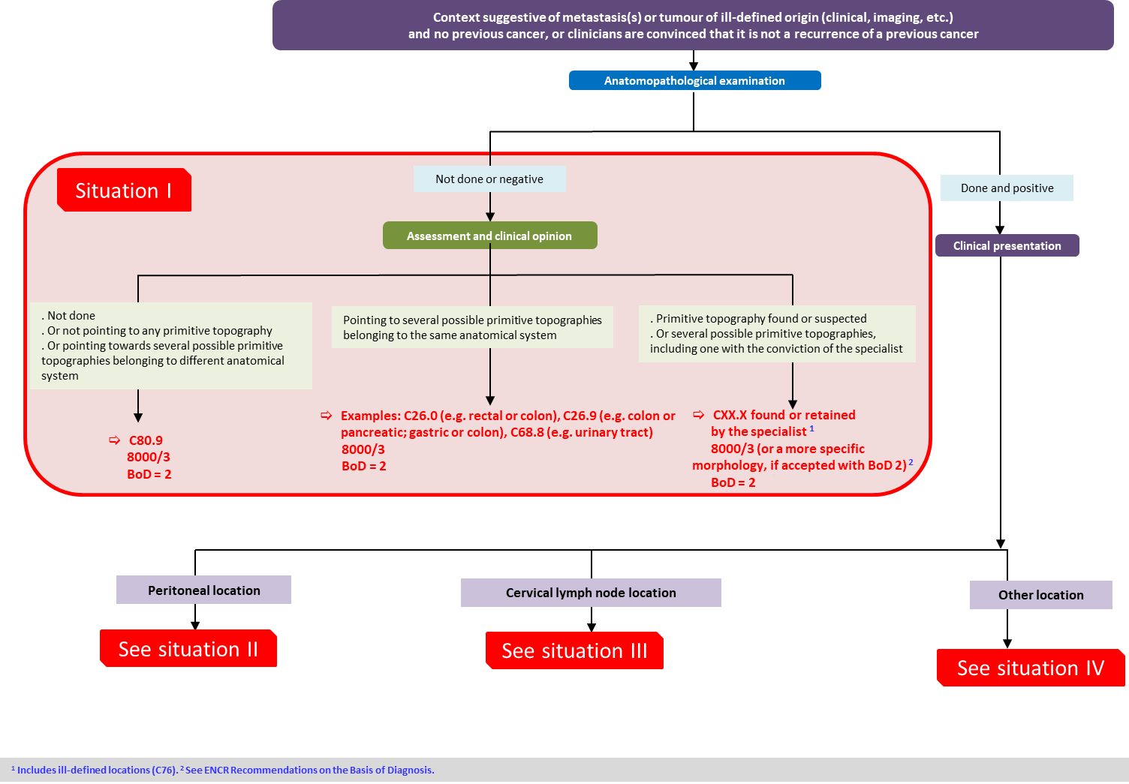

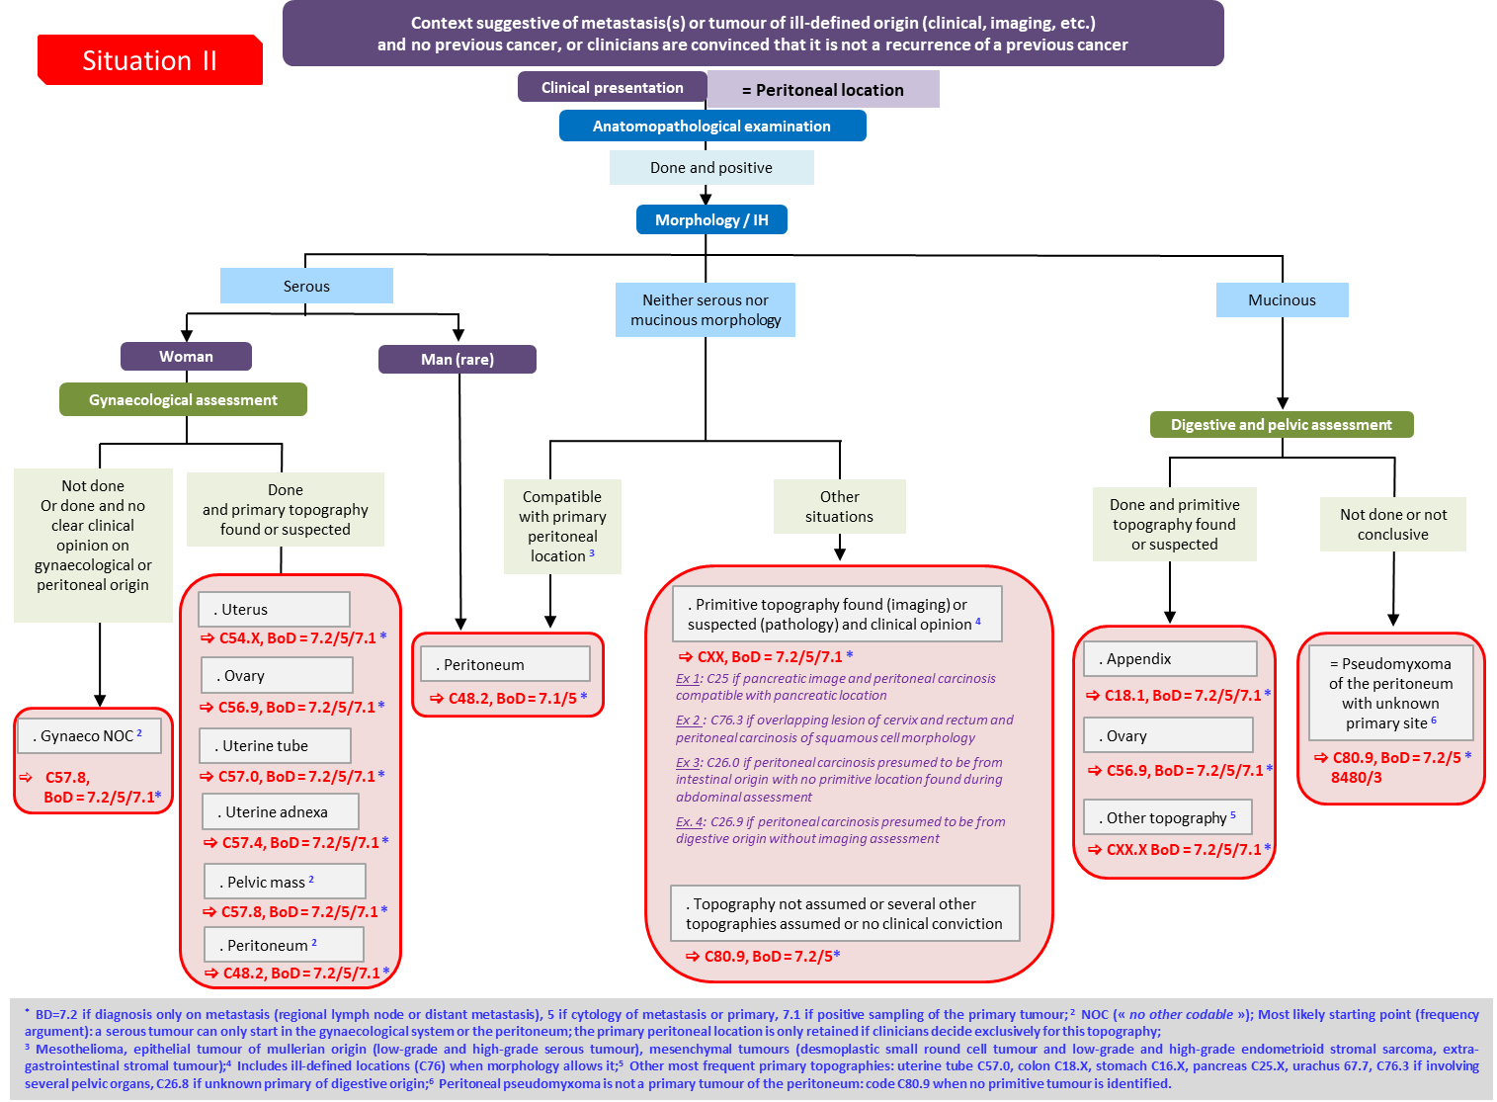

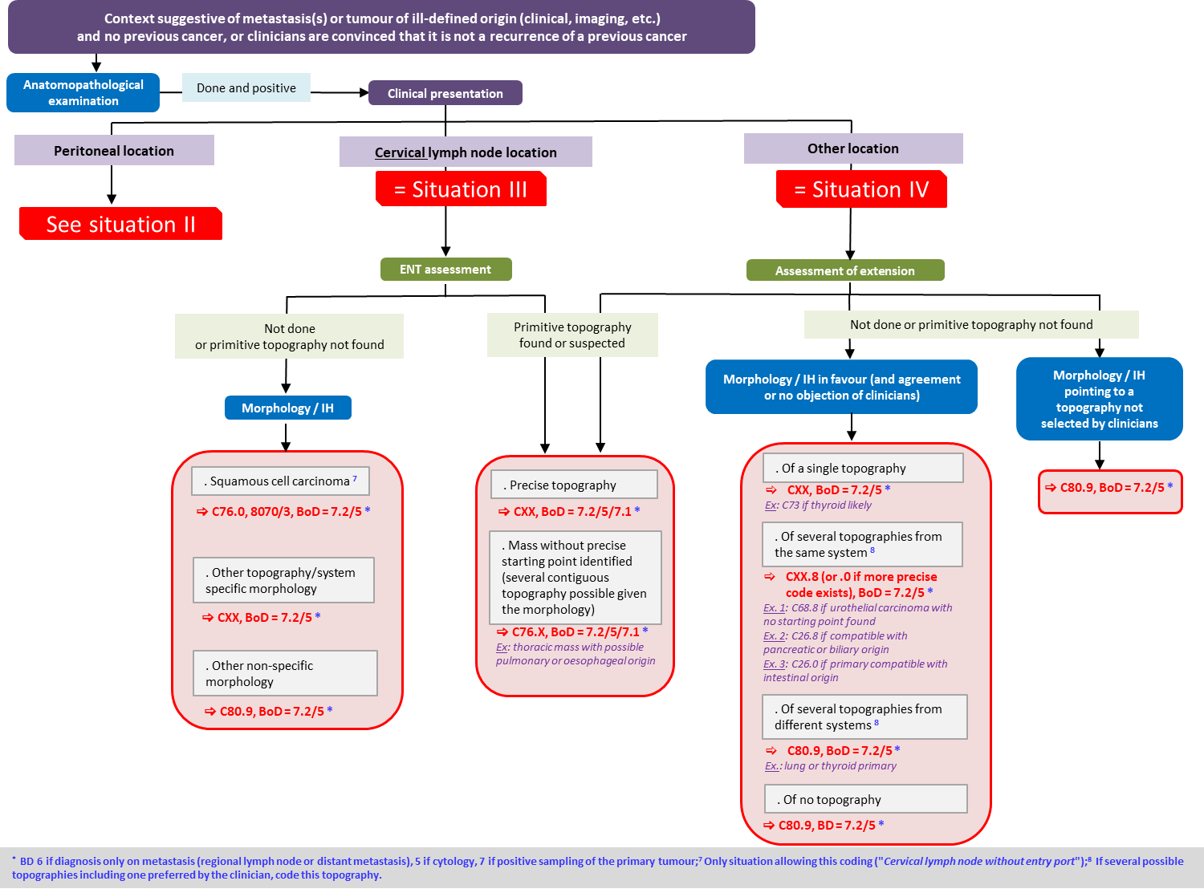

Annex: Working Group Members

Laetitia DAUBISSE-MARLIAC, Tarn Cancer Registry, Francim network (France)
Patricia DELAFOSSE-ARDUIN, Isere Cancer Registry, Francim network (France)
Méric KLEIN, Belgian Cancer Registry
Liesbet VAN EYCKEN, Belgian Cancer Registry
Gabrielle GRAN, Regional Swedish Cancer Registries, Regional Cancer Centres (Sweden)
Lotta ÖRNDAL, Swedish Cancer Registry
Lise ENERSTVEDT, Cancer Registry of Norway
Ann Helen SEGLEM, Cancer Registry of Norway
Ok Målfrid MANGRUD, Cancer Registry of Norway

A. Krämer, T. Bochtler, C. Pauli, G. Baciarello, S. Delorme, K. Hemminki, et al., on behalf of the ESMO Guidelines Committee. Cancers of unknown primary site: ESMO Clinical Practice Guidelines for diagnosis, treatment and follow-up. Annals of Oncology, mars 2023;34(3):228‑46. doi:10.1016/j.annonc.2022.11.013.
In ICD-O-4, cancer of the oesophagogastric junction will be coded C16.7 (new ICD-O code).
Justification: Metastatic cervical lymphadenopathy of squamous cell carcinoma without an identified primary tumour is defined as metastatic cervical lymph node disease without a primary tumour found in the upper aerodigestive tract (UADT) following an appropriate comprehensive assessment (C00-C14, C32, upper C15). C14 is too restrictive because C32 and C15 are not considered and C80 does not provide information that these are isolated cervical lymph node metastasis. Therefore, C76.0 seems to be the most appropriate topographical code. The TNM V8 classification page 56 suggests staging these tumours as head and neck tumours.

